***DATA VISUALIZATION***

**Q1.** Create a sample table in postgres/mysql with following columns.

Table Name : cdac_power_bi

Column Name – varchar

Id- integer

Age- integer

Dob – date

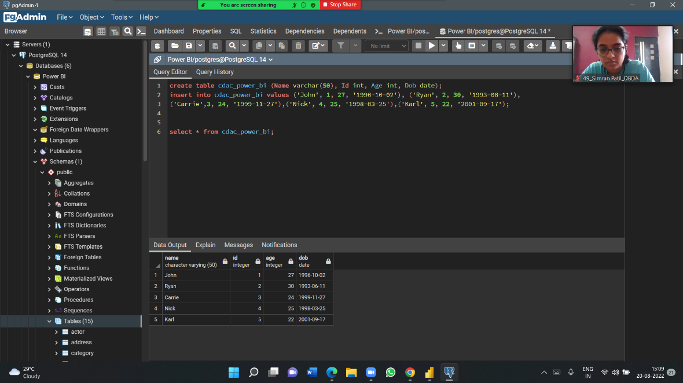

Insert 5 dummy rows into it and then connect to superset and populate

1. Table Chart 2. Card chart showing max age

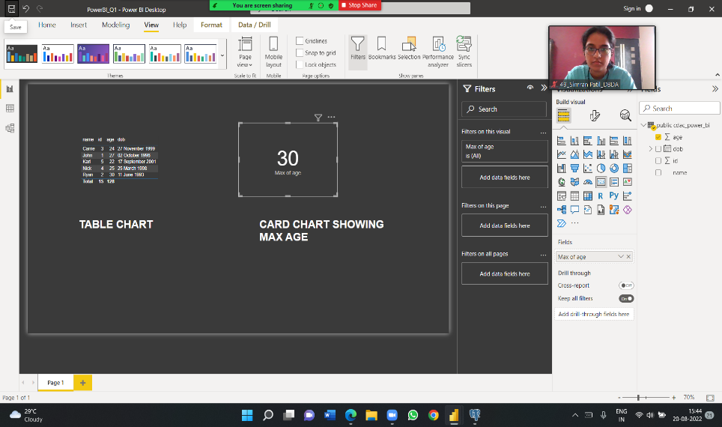

**Q2**. On product_table data set do the following

● Create table chart with title , vendor,customer name,quantity,price,city.

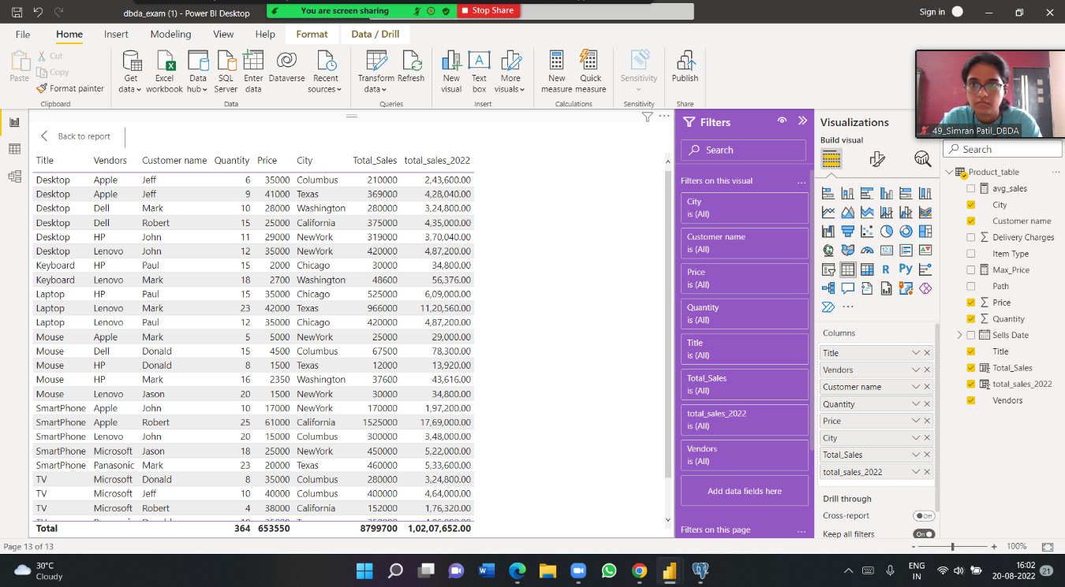

● Add new calculated column naming total_sales which is derived from quantity * price

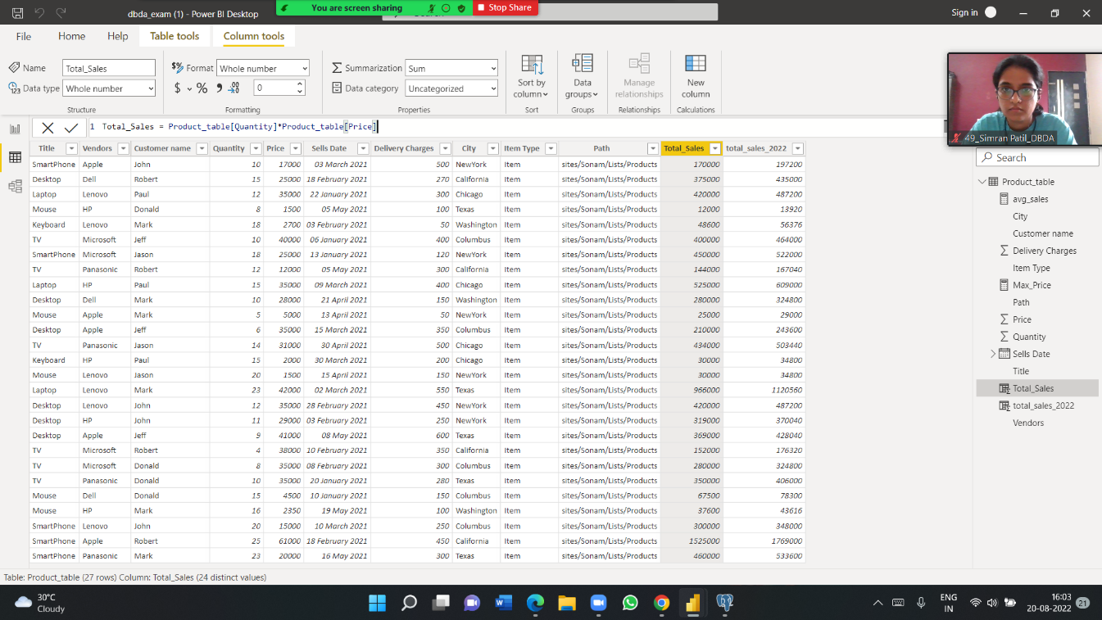

● Add new measure naming max_price to get max of price column and then display every vendor max price in table chart

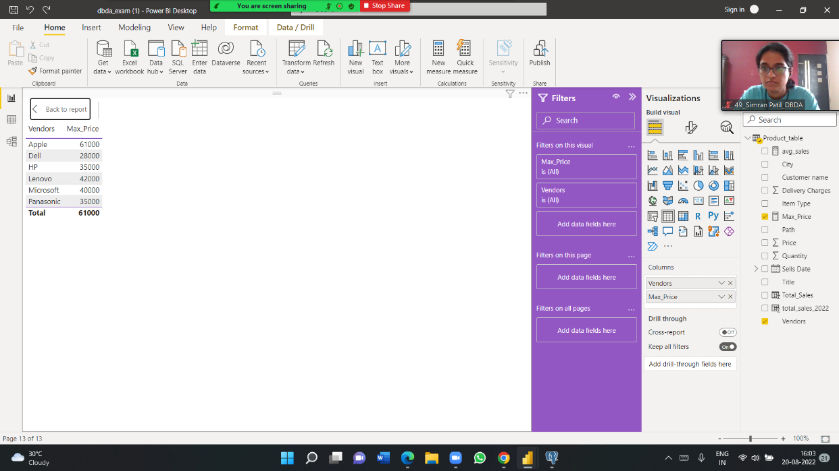

* Create pie chart showing the value and percentage of quantity by vendors

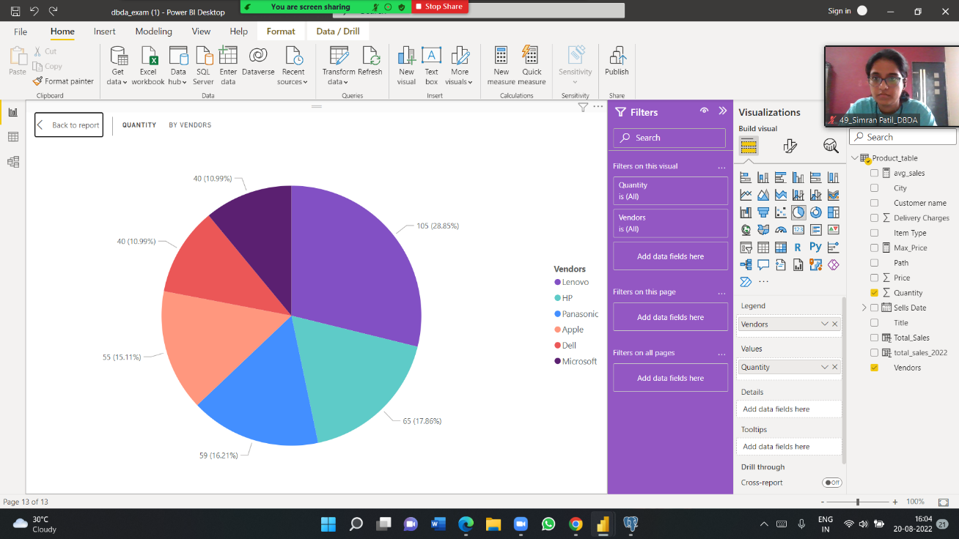

● Create one more column naming total_sales_2022 which is derived from quantity * price * 1.16

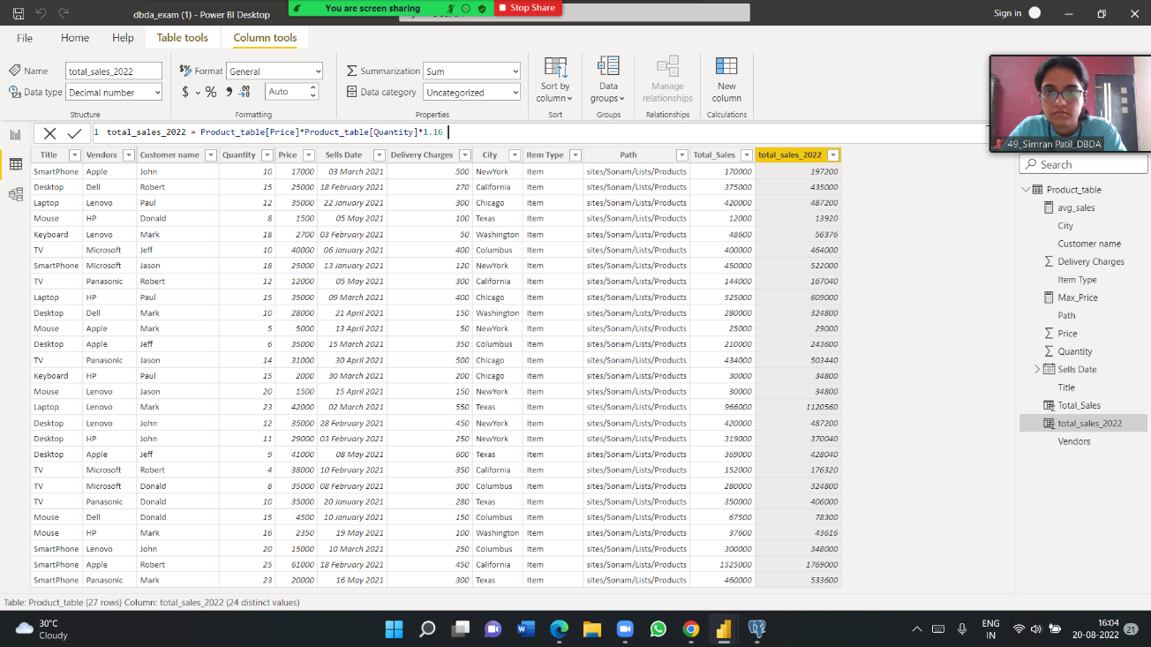

● Create clustered column chart showing both total_sales and total_sales_2022

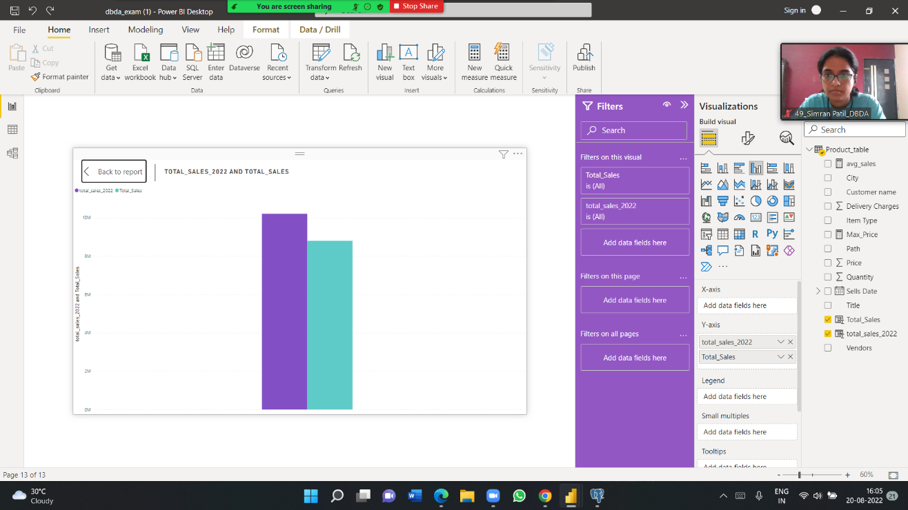

● Create a slicer chart of price

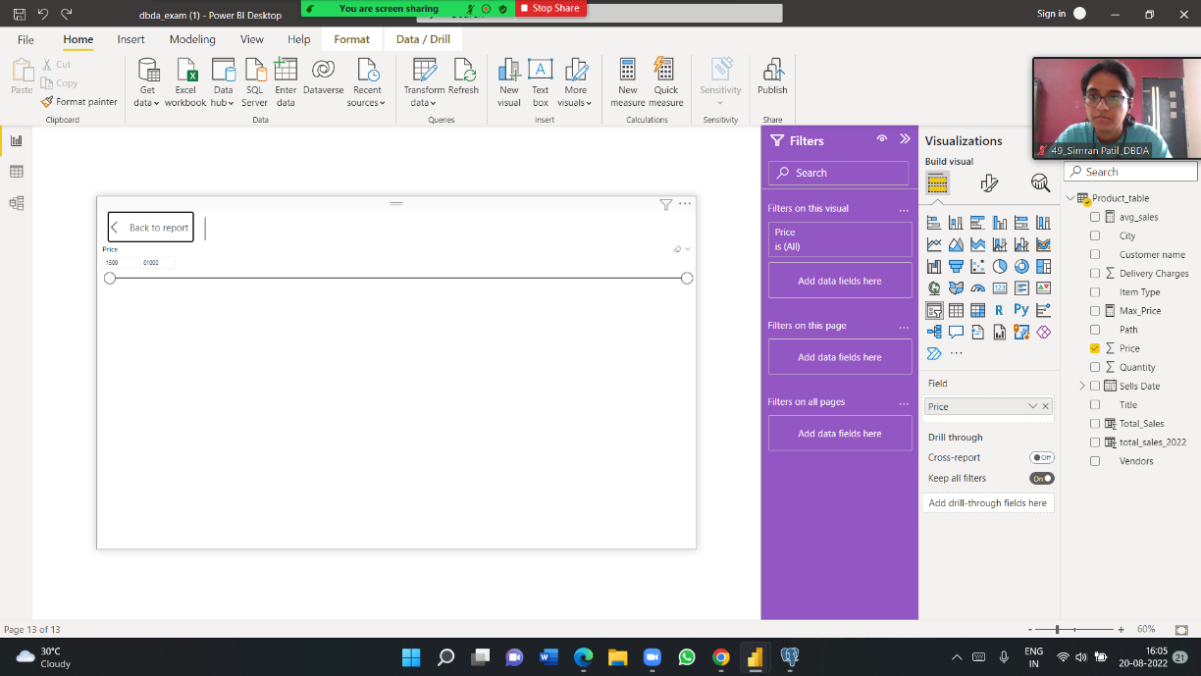

● Calculate avg sales and show in tile

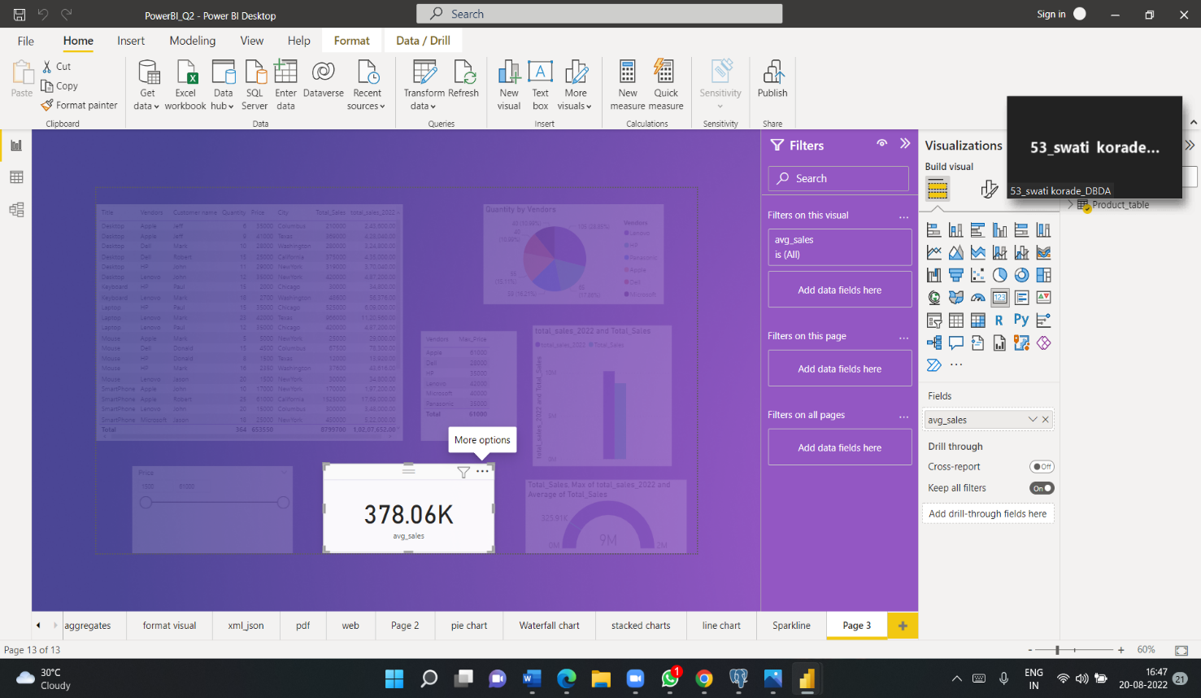

● Create gauge chart with ○ value as total_sales ○ Maximum value as max of total_sales_2022 ○ Target Value as average of total_sales.

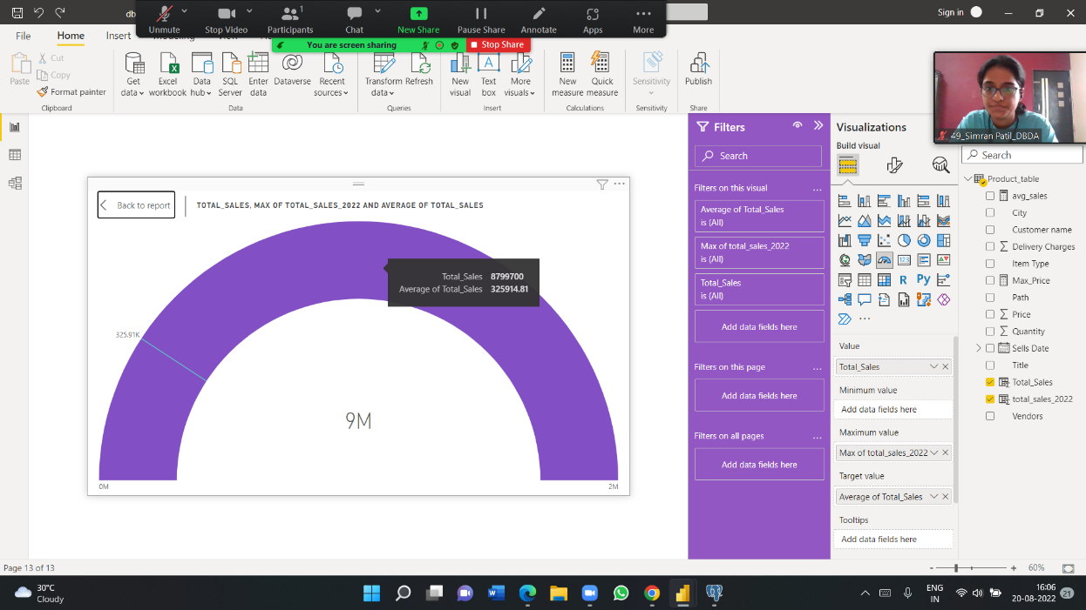

***OVERALL VISUALIZATION***

